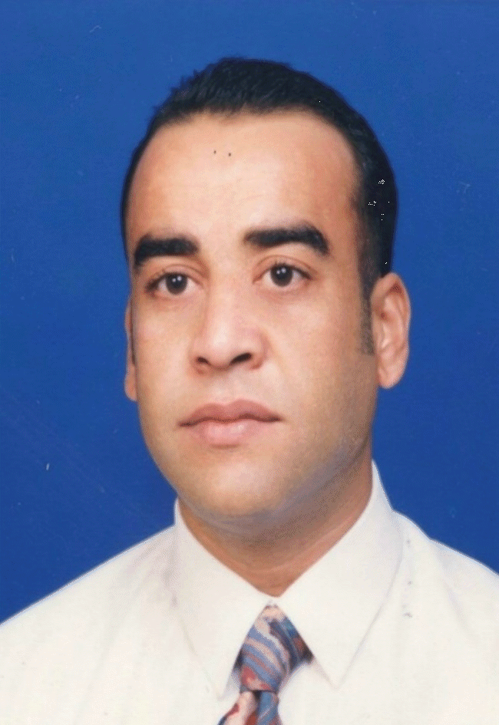
CURRICULUM VITAE

NAME: | Amjed (Moh’d Sami) Mustafa Shatnawi
DATE OF BIRTH: |  | 1/1/1965
NATIONALITY: | Jordanian
PROFESSION: | Geological Engineer
MARITAL STATUES: | Married with two children
MILITARY STATUES: | M Free
HOME COUNTRY PERMANENT ADRESS: | Irbid - Jordan
EDUCATION:

Basic Education
. University of Jordan
Amman – Jordan
ph D in Geology June 2001
Thesis titled:
"Study and Modelling of Aquifer Elasticity of Overpressurized B₂/A₇ Aquifer
in Northwest Irbid-Jordan
Using geotechnical methodology and GIS techniques -

. Al al-Bayt University
Mafraq - Jordan
Master of Science March, 2002
Thesis titled:
“Hydrological and Hydrochemical Study for Zeglab Dam / Jordan”

. Hacttepe University

Ankara -Turkey
Bachelor of Science June, 1997

Geological Engineering (Hydrogeology option)

. Shaheed Wasfi Al-tell High School

Irbid – Jordan

General Certificate of Education August, 1983

Additional Education / Training

- English Language course in London – UK January, 1984

- Turkish Language course in Ankara - Turkey September, 1991

- Member of Jordanian Engineer’s Society since August 1997.

- Stager Engineer at Ministry of Water and Irrigation in the April, 1999
Field of Surface and Ground Water Hydrology.

-Training Course in Solid Waste Management at UK July, 2000
(Corporation between British Council, Al al-Bayt Uni. and
Liverpool John Morris Uni.)

- Training course in Wastewater Treatment and Reuse at CITAT / Tunis.
September, 2003

- Training course in Information Technology at Salford Uni. / UK. March, 2004

- Second Regional Training Course in wastewater Management and Treatment
Founded by the EU and co-founded by the German Government at LAU Uni.
In Beirut/ Lebanon. November, 2005

- Leadership Course on Sound Waste Management Held in United Nations Uni. /
International Leadership Institute – Amman/Jordan. August, 2006

- Third Regional Training Course in wastewater Management and Treatment
Founded by the EU and co-founded by the German Government
at TUHH in Hamburg Uni./ Germany. September, 2006

- Training course in Using Blackboard Program for University Teaching at Al al-Bayt Uni. / Jordan. May, 2005

- Basic Computer and Internet skills.
- Remote Sensing and GIS Software Skills.

Published Researches
- "INVESTIGATING THE ACTUAL STORAGE CAPACITY OF SHARHABIEL BIN HASANAH DAM"
Accepted in Almanara Magazine- Al al-Bayt University February, 2004

- "STATISTICAL ANALYSIS OF RECORDES AT THREE MAJOR METEOROLOGICAL STATIONS IN JORDAN"
Accepted in Almanara Magazine- Al al-Bayt University November, 2004
- "SILTATION OF THREE SMALL RESERVOIRS IN JORDAN"

First Symposium on Dams Management & Operation in the Kingdom

Of Saudi Arabia May, 2006
- "SILTATION OF ALGHADEER ALABYADH RESERVOIR IN JORDAN”

Jordan Journal of Civil Engineering, Vol. 6 No. 1 January 2012

Memberships

- Member of Jordanian Engineer’s Society. August 1997
- Member of Jordanian national comity for International
Hydrology Program (IHP) /UNISCO. October 2006
- Accreted head of Site Investigation and Soil Testing Material;
Of the Jordanian Engineer’s Society May 2008

Languages

English
Speak Read Write
Good Good Good

Turkish
Speak Read Write
Good Good Good

WORK EXPERIENCE:
DURATION: | (2003 – up to now)
EMPLOYER: | Al Al-Bayt University/ Mafrak-Jordan
POSITION: | Lecturer
COURSES TOUHT: | - Hydrology.  - Hydrogeology  - Engineering Geology  - Environmental Engineering  - Soil  - Sedimentary Rocks  - Principles of Survey  - General Geology

PROJECTS SUMMARY
- Efficient Management of Wastewater, EMWater Project funded by the European Union. April, 2003
- Developing Water Resources Management using Information Technology funded by the World Bank. July, 2004
- Wadi Arab dam Project, Hydrological and Hydrogeological investigation for Wadi Arab dam catchment area including in-situ permeability tests and siltation of the dam. January,2005
- Project of Assessment of treated Wastewater Quality under different climate change Scenarios in Jordan. June 2011

DETAILED RESPOnSIBILITY/DUTIES
• Hydrogeological and geological field investigations and groundwater exploration and borehole logging
•Designing and preparation of pumping tests to estimate hydraulic characteristics of Aquifers.
• Drawing, studying/analyzing groundwater flow lines.
• In-Situ and laboratory Tests for permeability.
• Groundwater and Surface water Budget Calculations.
• Simulation of climatical, environmental and surface and groundwater interactions
• Geological and Hydrogeological mapping and study of regional aquifer systems

DURATION: | 2006 – 2008
EMPLOYER: | Engineering Axis for Studies, Amman- Jordan
POSITION: | Site Investigation Chief Engineer
PROJECT NAME: | Various Projects for the construction industry in Jordan
PROJECT CLIENT: | Various clients from governmental and private Entities

PROJECTS SUMMARY
- Various complex buildings sites, bridges sites and road crossing sites geotechnical investigation for design at various locations in JORDAN, client was Greater Amman Municipality.
- Various sites of high rise embankments roads and deep excavations at various locations in Jordan; site investigation, slope stability, providing engineering solutions for retaining walls, gabions and water bearing formations. Clients are from various sectors of private and governmental entities
- Al-Ktefah Equestrian Village geotechnical, hydrological, environmental impact and noise study base-line investigation. Client was Tamleek of Jordan
- Jerash Waste Water Treatment Plant; geotechnical investigation for site, design of the treatment plant structure foundations and design of rock fill embankment on expansive soils. Client was Concord engineering Contractors
- Ahl El Azm Village Amman - JORDAN: the project was site exploration and geotechnical investigation for foundation design of 3000 housing units of sizes ranging from 90 to 360 m² Design of foundations, investigation of borrow materials, excavations depth and stability within the site area of 10⁷ m², geotechnical investigation of roads and streets network sites within the overall project site.
- Amman – City dale Castle High rise embankment roads geotechnical investigation and slope stability analysis for a ring road connecting and encircling a tourist attraction site at the Al-Qalaa mountain – Amman – JORDAN. Client was Greater Amman Municipality

DETAILED RESPONSIBILITY/DUTIES
Responsibilities included:
• Site exploration.
• Geological and hydrogeological field investigations and borehole logging.
• Description of Material
• Rock and soil testing material.
• Preparation of the Final report.

DURATION: | 1998 – 2003
EMPLOYER: | Engineering Axis for Studies, Amman- Jordan
POSITION: | Site Investigation Engineer
PROJECT NAME: | Various Projects for the construction industry in Jordan
PROJECT CLIENT: | Various clients from governmental and private Entities
PROJECTS SUMMARY
- Various complex buildings sites, bridges sites and road crossing sites geotechnical investigation for design at various locations in JORDAN, client was Greater Amman Municipality.
- Various sites of high rise embankments roads and deep excavations at various locations in Jordan; site investigation, slope stability, providing engineering solutions for retaining walls, gabions and water bearing formations. Clients are from various sectors of private and governmental entities
DETAILED RESPONSIBILITY/DUTIES
Responsibilities included:
• Site exploration.
• Geological field investigations and borehole logging.
• Description of Material
• Rock and soil testing material.
• Assisting in preparation of the final report.

DURATION: | 1997 – 1998
EMPLOYER: | Ministry of Water and Irrigation, Amman, Jordan
POSITION: | Junior Hydrogeological Engineer
PROJECT NAME: | Yarmouk River Basin
PROJECT CLIENT: | Ministry of Water and Irrigation, Amman, Jordan

PROJECT SUMMARY
- Yarmouk River Basin Project: A comprehensive Hydrological and Hydrogeological investigations for Yarmouk River Basin which is located in the northern part of Jordan ; Climatical data analysis, Surface runoff coefficient estimation,Surface water and groundwater budget calculation,Drilling boreholes, pumping tests to estimate hydraulic characteristics for Aquifers.

DETAILED RESPONSIBILITY/DUTIES
Responsibilities included is assisting in:
•Drilling boreholes, development, designing and installation of production wells.
• Hydrogeological and geological field investigations and groundwater exploration and borehole logging
•Designing and preparation of pumping tests to estimate hydraulic characteristics for different Aquifers.
• In-Situ and laboratory Tests for permeability.
• Drawing, studying/analyzing groundwater flow lines.
• Groundwater and Surface water Budget Calculations.
• Groundwater quality estimation for potable and public supply and agricultural usage.
• Simulation of climatical, environmental and surface and groundwater interactions
• Geological and Hydrogeological mapping and study of regional aquifer systems

CONTACT INFORMATION

Mobile Number | 07775654334
E-Mail Address | Amjedshatnawi@yahoo.com

