CURRICULUM VITAE
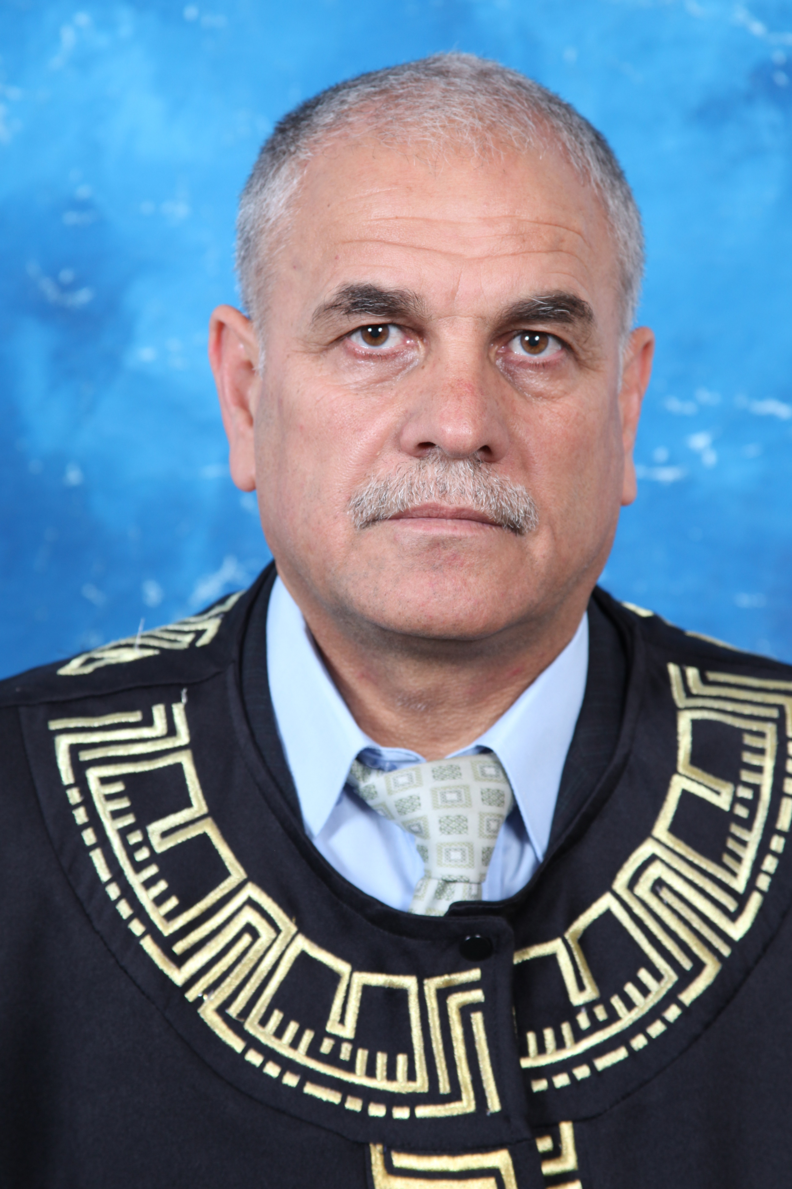
Ibrahim Bany Yaseen, Ph.D.
Institute of Earth and Environmental Sciences
Al al-Bayt University
Mafraq- Jordan
Phone: (O) 00962-26297000 ext. 2755
Mobile: 962-77-7460329
Phone: Home (00962 65351654
E-mail: ibanyyaseen@yahoo.com
Personal:
Date of Birth: December 23 / 1960
Place of Birth: Kufrlma, Jordan
Nationality: Jordanian
Marital Status: Married (four children)

EDUCATIONAL BACKGROUND:

1- Ph.D. (Doctor Philosophy) in Applied Geology (Geochemistry, Mineralogy and Petrology), June 2007. Faculty of Science, Department of Geology and environment at University of Jordan.
Thesis title: Geochemistry, Mineralogy and Petrology of the Calc-Alkaline Granitoids of Wadi Huwar Area Southwest Jordan and their Economic Potential.
2- M.Sc. Applied Geology (Water Geochemistry), June 1987, Faculty of Science, Department of Geology and Environment at University of Jordan.
Thesis title: Dead Sea Water Geochemistry.

3- B.Sc. Applied Geology (Hydrology), July 1984, King Abdulazz University Jeddah, Saudi Arabia.
4- Altawjeehi, Secondary Scientific Education, August 1979, Dair Abu said High secondary school, Jordan.

WORK HISTORY:
- 2016-2018: : Associate Professor in Institute of Earth and Environmental Sciences, Al-al-Bayt University. Jordan.
- 015-2016: Director of Water Environment and Arid region Research Center, Al-Bayt University. Jordan
- 2014-2015: Director of Water Environment and Arid region Research Center, Al-Bayt University. Jordan
3- 2013-2014: Vice Dean in Institute of Earth and Environmental Sciences, Al-al-Bayt University. Jordan
4- 2010 – 2013: Assistant dean for student affairs in Institute of Earth and Environmental Sciences, Al-al-Bayt University. Jordan
5- 2010-2012: Assistant Professor in Institute of Earth and Environmental Sciences, Al-al-Bayt University. Jordan

6-2009-2010: Full time lecture at Institute of Earth and Environmental Sciences, Al-al-Bayt University (Petrology and Mineralogy Course),

7- 2008 -2009: Senior in Geochemical Exploration (Detailed Geochemical Survey for Trace and Heavy mineral (Precious metals).Natural Resources Authority, Geochemistry Division

8- 2003 – 2007: Teaching Assistant at Geology Dept, the University of Jordan, teaching courses were General Geo. Lab, Optical Mineralogy Lab, Igneous Petrography Lab and General geology course.

9-2002-2004 - Engaged mainly in the prospecting for hydro geochemistry (Geothermal project in middle Jordan). Natural Resources Authority, Geochemistry Division.

10- 1989 - 2001, Exploration Geochemist in arid zone (Aqaba area) (rock, stream, heavy mineral, water sampling and geochemical interpretation of data (Geochemistry Division, Natural Resources Authority (NRA) of Jordan).

11- This involved geochemical mapping, geochemical sampling and study of the distribution of trace and major elements and full time of Geochemical and mineral exploration of Aqaba – Araba Complex within the scope of technical cooperation between NRA and BRGM of France.

COURSES TAUGHT:

Graduate Courses at Institute of Earth and Environmental Sciences, Al-al-Bayt University
- Advance Mineralogy
- Advance Geochemistry
- Ore deposit
- Industrial Rocks and Minerals

Undergraduate Courses at Institute of Earth and Environmental Sciences, Al-al-Bayt University

Petrology
- Petrology Lab

Mineralogy
- Mineralogy Lab

Crystallography and Mineralogy

Crystallography and Mineralogy Lab

Optical Mineralogy

Optical Mineralogy Lab
- Industrial Rocks and Minerals
- Applied Geochemistry
- Applied Geochemistry Lab
- Geochemical Exploration
- Management of Arid and Semi-Arid Lands
- Hydrogeology Lab
- Geology 2
- Practical Geology 2
- Analytical technique
- Earth Sciences

PUBLICATIONS:
Refereed Indexed Journals:
- Ibrahim Ahmad Ali Bany Yaseen, 2017. Geochemistry of the Ground Water in the Sinkhole Area at Ghor El Haditha, Southeast Dead Sea, Jordan. Journal of Natural Sciences Research, Vol.7, No.2, pp.1-11.

- Abedelkarim Al-Saudi1 and Ibrahim A. Bany Yaseen. 2017. Geochemical and Geo-thermometers Characteristics of Thermal Groundwater at Khan Ezabeeb Area, in Central Jordan. Journal of Natural Sciences Research, Vol.7, No.4, pp. 23-43.

- Ibrahim Ahmad Ali Bany Yaseen and Alaa Hamed Al Elaimat, 2016. Assessment of the Heavy Metal Pollution in the Surface Sediments along Upstream at Wadi Al-Arab, Jordan. Journal of Natural Sciences Research, Vol.6, No.20, pp. 1-12.

- Ibrahim Ahmad Ali Bany Yaseen and Alaa Yaser Abidrabbu, 2016. Mineralogy, petrology and Geochemistry of the Basalt flows at Ash-Shun Ash-Shamaliyya Area, North West Jordan. Earth Sciences, vol. 5, No. (6): pp. 82-95.

- Ibrahim Ahmad Ali Bany Yaseen. 2016. Petrography, Geochemistry and Petrogensis of Basalt Flow from Ar-Rabba Area, Central Jordan, International Journal of Geosciences, vol.7, pp. 378-396

- Ibrahim Ahmad Ali Bany Yaseen. 2015. Geochemical Exploration for Gold and the
Association of As-Cu-Pb-Sn-Zn-Li in the Upper Proterozoic Granitoids of the Wadi Rumman Area, Southwest Jordan, International Journal of Geosciences, vol. 6, pp. 1140-1153.

- Ibrahim A. Bany Yaseen and Zayed Al-Hawari. 2015. Assessment of Heavy Metal Pollution of Surface Sediments in Wadi Shu'ayb, Jordan. Jordan Journal of Civil Engineering, Vol. 9, No.3.pp.303-313.

- Ibrahim Ahamad Ali Bany Yaseen. 2014. Contribution to the Petrography, Geochemistry and Petrogenesis of Zarqa – Maʹin Pleistocene Alkali Olivine Basalt Flow of Central Jordan. International Journal of Geosciences, Vol. 5, pp. 657-672. Published Online May 2014, http://www.scirp.org/journal/ijg.

- Ibrahim Ahamad Ali Bany Yaseen. 2014. Petrography and Mineral Chemistry of the Almanden Garnet, and Implication for Kelyphite Texture in the Miocene Alkaline Basaltic Rocks North East Jordan. International Journal of Geosciences, Vol 5, pp.222-237. Published Online February 2014 , http://www.scirp.org/journal/ijg.
- Ibrahim Ahamad Bany Yaseen, Hani Al-Amosh, Mohammad Al-Farajat and Adulraouf Mayyas. 2013; Petrology and Mineralogy of Roman Mortars from Building of the Ancient City of Jerash, Jordan. Elsevier, Construction and Building Material, Vol.38, pp.465-471.

- Abdulraouf Mayyas, Khaled Douglas, Thorsten Hoffmann, Ute Thorenz, Ibrahim Bany Yaseen, El-Khalili Mohammed, 2013. Organic Residues Preserved in Archeological Ceramics from the early Bronze age site of khirbet Al-Batrawy in North –Central Jordan, Journal Mediterranean Archaeology and Archaeometry (MAA), Vol.13, No. 2, pp. 189-206.

- Zayed Al-Hawari and Ibrahim A. Bany Yaseen, 2012. Clay Mineralogy of the soils above Basalt from Azraq Area, Jordan. Jordan Journal of Civil Engineering, Vol. 6 No.3. pp. 373-384
- Ibrahim A. Bany Yaseen, Zayed Al-Hawary and, Abdulla A. Diabat. 2010. Petrology Geochemistry, Petrogenesis and Reactivation of Volcanic Tuffs at Dair El-Kahif Area, NE-Jordan. Jordan Journal of Civil Engineering, Vol. 4, No.4. pp. 336-350.

Internal Reports:

- Ibrahim A. Bany Yaseen and A. Dalou. 1991. Geochemical Exploration for Uranium in Jable El-Mubarak Sheet, Aqaba area, Natural Resources Authority (NRA), Amman. Jordan.

-Geochemical Division; (Ibrahim A. Bany Yaseen). 1992. Geochemical Orientation Survey of South Jordan, Aqaba and Araba area complex, NRA Amman, Jordan

- BRGM and NRA staff (Ibrahim A. Bany Yaseen). 1994. Geochemical and Mineral Exploration of Aqaba – Araba Complex (cooperation between BRGM and NRA staff). NRA, Amman, Jordan.

-A. Dalou , Ibrahim Bany Yaseen and S. Mahmoud. 1998. Geochemical prospecting for minerals of Basalt and Dolorite Dyke Along Quwayra, Mudawwara Areas /SW Jordan, NRA. Amman, Jordan

- A. Dalou , I. Bany Yaseen and S. Mahmoud. 1999. Geochemical prospecting for minerals Jabal Al Qannassiya sheet Area. NRA. Amman, Jordan.

- Ibrahim A. Bany Yaseen. 1999. Geochemical studies for sinkholes in Ghour Hadetha Areas, , NRA. Amman. Jordan.

- I. Bany Yaseen , A. Dalou , and S. Mahmoud. 2000. Geochemical prospecting for minerals Wadi Huwwar Area (Ras En Naqab sheet). NRA. Amman. Jordan.

- A. Dalou , I. Bany Yaseen and S. Mahmoud. 2001. Geochemical Prospecting for Minerals Jabal Ladghayn Dubaydib sheet Area, , NRA. Amman. Jordan.

- Ibahim Bany Yassen and Abed El Rahem Dalou. 2001. The Geochemistry of Basalt in central Jordan, NRA, Amman. Jordan.

- Ibrahim Bany Yaseen and Abed El Karim. Saodi. 2002. The Geochemistry of the thermal fluid in central Jordan, NRA. Amman. Jordan

-H. zubie, Ibrahim Bany Yassen and M. Okour. 2003. The Geochemistry of the Mud of the Dead Sea area, .NRA, Amman. Jordan.

- I. Bany Yaseen, A. Dalou and S. Mahmoud. 2004. The Geochemistry of the Grainphat volcanic rock in Um Ishrain area,.NRA, Amman. Jordan.

- Abed El Rahem Dalou , Ibrahim. Bany Yaseen and Saleem Mahmoud. 2006. Geochemical Orientation Survey for Minerals (Basalt of North East Jordan Areas), Natural Resources Authority, Amman, Jordan.

- Abed El Rahem Dalou and Ibrahim Bany Yaseen. 2007. Geochemical prospecting for minerals of Wadi El Marsad Southern Jordan, Natural Resources Authority, Amman, Jordan.
-Ibrahim A. Bany Yaseen. 2007. Geochemistry, Mineralogy and Petrology of the Calc-Alkaline Granitoids of Wadi Huwar Area Southwest Jordan and their Economic Potential. University of Jordan, Ph.D. Theses, 216pp, (University of Jordan), Amman. Jordan.

- Ibrahim A. Bany Yaseen and A. Dalou. 2008. Geochemistry and Mineralogical Exploration of Wadi Huwar Area Southwest Jordan. Natural Resources Authority, Amman, Jordan.

Conference:

- Participation in the conference (dialogue academia and the private sector for the development of the workforce), 20/7/2011, the supervision of the Higher Education Accreditation.

- Participation in the Fourth World Conference for Renewable Energy and Energy efficiency in desert areas in 2013, the supervision of the University of Jordan, Faculty of Engineering.

M.Sc. THESES SUPERVISED

1- Mineralogy, Petrology and geochemistry of the Basalt flows at Ash-Shuna Ash-Shamylia Area, North West Jordan, by Ala'a Yaser Abed-Rabbouh, Institute of Earth and Environmental Sciences, Al Al-Bayt University, May 2014.

- Study the possibility of pollution by heavy metals on surface sediment along upstream at
Wadi Al-Arab, Jordan, By Ala’a Al Elaimat, Supervisor Ibrahim Bany Yaseen
December 2014.

3-Assessment of Ground water Pollution with Heavy Metal in Al-akaider area North Jordan
By Tareq Awad Al _Naeem Supervisor Ibrahim Bany Yaseen, Co-supervisor Dr. Moayyad Shwaqfah, May 2015

4- Assessment of pollution by heavy metals in surface sediments at Wadi Al-Wala, Jordan by Walid Ahmad, Supervisor Ibrahim Bany Yaseen, November 2015

5-Assessment of Ground water Pollution with Heavy Metals in Al-zaatari area, North Jordan, By Bayan Majed Al_Zboon, Supervisor Ibrahim Bany Yaseen, Co-supervisor Dr. Moayyad Shawaqfah, April 2016.

6-Mineralogy, Petrography, and Geochemistry of Basalt Flow at AL Azraq AL Shamali area, East Jordan. Supervisor Ibrahim Bany Yaseen, April, 2017

Reviewers Journal :
1- Earth Sciences (EARTH) journal, 2014, (Science Publishing Group)
http://www.sciencepublishinggroup.com/j/earth
The Official Publication of Science Publishing Group

- African Journal of Engineering Research, 2013, www.netjournals.org
- International Journal of Agricultural Policy and Research http://www.journalissues.org/IJAPR/
- Issues in Scientific Research
http://www.journalissues.org/ISR/

- Jordan Journal of Earth and Environmental Sciences ( JJEES)

- Journal of Geography, Environment and Earth Science International
- African Journal of Engineering Research, www.netjournals.org
- International Research Journal of Public and Environmental Health
http://www.journalissues.org/IRJPEH/
- Physical Sciences Research International
www.netjournals.org

