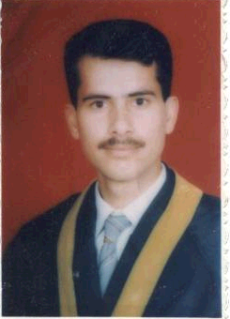
C.V

Personal Information:

- Name: Sultan Essa Ayash Al-Rwis
- Place and date of birth: Al-zarqa 4/20/1975.
- Address :Jordan -Mafraq
- Phone:009622-6264479
- Nationality: Jordanian
- E-mail:sultan@aabu.edu.jo

Scientific qualification:-

- B.Sc. in Biological sciences from Jordan university in 1997(good).
- M.Sc. in Biological sciences from Al-bayt university in2002(85.5%).
- title of research(Allelic Frequency Distribution of Some Genetic loci in Black Jordanian Using the PCR Technique).

Work experience:-

- Assistance research at Criminology lab from 1997-1998
- Teacher at MEOJ from 1998 – 2002 .
- *Research and teaching assistance at the Biological Dep. Al-albyt university(Jordan) from 2002 –2004 for the following lab. courses:-
  - General Microbiology.
  - Biochemistry.
  - Plant and Animal Tissue Culture.
  - Medical Biological Analysis.
  - Parasitology and immunology.
  - Histology .
  - Animal biology .
  - Animal Physiology.
  - Plant physiology
  - General Biology.
- Lecturer at the Biological Dep.Al-albyt University (Jordan) from 6/21/2004 –present in Following Subjects ( in addition to labs ) :
- Computer Applications in biological Sciences and bioinformatics .
- Environmental Science and Pollution .

Skills :
- ICDL 2003 .
- English ( Writing/ Reading/ Speaking ) .

Other Activities :
- Research in eco-physiology : ( The Effects of Heavy Metals in Respiratory System of Gobi Fish ). Unpublished, 1997.
- A sharing Member at Project of ( The Ecology and Healthy School ) in Jordan .

