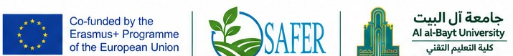
SAFER project:
The SAFER project falls under the European Union’s program for education, training, youth, and sport (Erasmus+), aiming to enhance the capacities of higher education institutions and modernize their academic and research programs to accelerate climate resilience, green growth, and sustainable agriculture. Furthermore, the project seeks to deliver innovative solutions and smart agricultural strategies that tackle climate challenges and enhance regional food security through knowledge transfer and modern resource management technologies. Its core objectives focus on updating curricula, empowering researchers and students, and strengthening collaboration between academia and the agricultural sector.
The strategic participation of Al-al-Bayt University / Technical Faculty as a key partner in this international consortium emphasizes the effective integration of advanced technology with agricultural and environmental sciences. Drawing upon its technical expertise in data analytics, Geographic Information Systems (GIS), remote sensing, and digital innovations, the Technical Faculty plays a vital role in creating high-impact tools for sustainable agriculture and optimized resource management. Consequently, this contribution directly reinforces the university’s standing as a premier regional center for technological innovation and green growth.

