CURRICULUM VITAE

A. Personal Data: -

Name: Yahya H Al-Rshoud
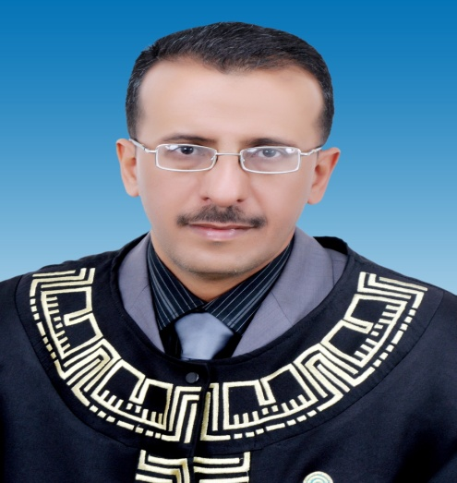

Place/Date of birth: Al-Mafrag, July 1st 1972.
Sex: Male.
Marital Status: Married.
Religion: Moslem.
Nationality: Jordanian.
Permanent Address: P.O. Box 21 Al Manshiah, Mafraq - Jordan.
Contact Number:
Mobile 00962-772306760
Mobile 00971554181209
E-Mail : yahya_yml@yahoo.com or
yahya-ymldg@aabu.edu.jo

B. Recent profile :

  - Education
BSN: Jordan University of Science and Technology, June 1995, Irbid, Jordan.
MSN: Jordan University of Science and Technology, May 1999, Irbid, Jordan.
Project Title: Assessment of Industrial Hazards in Al – Hassan City.

C. Teaching Courses
Community Health Nursing (Theory)
Community Health Nursing (Clinical)
Nursing Management and Ethics in Nursing Theory (Theory)
Communication Skills and Heath Education (Theory)
Health Assessment (Theory)
Health Assessment (Lab)
Adult Health Nursing 2 (Clinical)
Intensive Clinical Training (Clinical)

- Research
Area of interest:
Mr. Yahya Al Rshoud areas of interest are mainly on community nursing, also interested in occupational health nursing and their role in prevention of occupational health hazards, and school health.

Funded Research Project
  - Nil
- Publications
- looking at school nurses' roles in tackling overweight and obesity (2014).
- Perception and Attitudes of Jordanian Critical Care Nurses Toward Do-Not-Resuscitate (DNR) Orders (2014).
-Assessment the extent to which teachers in Jordan are aware of first aid measures ( 2018 under processing).

- Experiences: -

- Date: September 13th 2016 till now.
Position: Assistant Research and Teaching.
A member of education and training team in princes salama for nursing during this time, I have been lecturing nursing staff and provide hands on training and assisting in Competency program on annual basis, also training programs on community for school health, geriatric people, home visit for health education as a primary prevention from diseases.
Organization: Al al-Bayt University- Faculty of Nursing.

- Date: October 19th 2013 – September 13th 2016.
Position: lecturer and Assistant Dean for Clinical Training.
Organization: Al al-Bayt University- Faculty of Nursing.

- Date: September 13th 2009 – October 19th 2013.
Position: Assistant Research and Teaching.
Organization: Al al-Bayt University- Faculty of Nursing.

- Date: September 22nd 2001- 06/07/2009.
Position: Inservice Education Coordinator.
Organization: Sheik Khlifa Bin Zayed Hospital-Ajman, UAE.

- Date: March 3rd 2000- September 21st 2001.
Position: Casualty In charge & Nursing Supervisor.
Organization: Sheik Khlifa Bin Zayed Hospital-Ajman, UAE.

- Date: December 3rd 1996- March 1st 2000.
Position: Nursing Staff.
Organization: Ministry of Health and Health Care, AL Mafraq Hospital- Haemodialysis Unit- Jordan.

- Date: June 16th 1996-September 12th 1996.
Position: Nursing Staff.
Organization: AL Rashid Hospital (Psychiatry), Amman- Jordan.

- Date: December 1st 1995- June 10th 1996.
Position: Nursing Staff.
Organization: Luzimla Hospital (Medical Surgical), Amman-Jordan.

- Date: January 4th 1995- January 29th 1996.
Position: Nursing Staff.
Organization: Jerusalem Hospital (ICU), Amman-Jordan.

- Continued Professional Development:

1. Date: 2002 – 2006.
Subject: Acknowledging Contribution “ICU Course ( once every year )”.
Place: Sh. Khalifa Bin Zayed Hospital, Ajman – UAE.

2. Date: 2004 – 2006.
Subject: Acknowledging Contribution “ Mid – Line Management Course ( once every year )”.
Place: Sh. Khalifa Bin Zayed Hospital, Ajman – UAE.

3. Date: June 2006.
Subject: Estimation Certificate for ISO 9001:2000.
Place: Sh. Khalifa Bin Zayed Hospital & Ajman Medical District – UAE.

4. Date: December 2004 – April 2005.
Subject: Acknowledging Contribution - MOH Hospital Assessment Project.
Place: Northern Emirates, UAE.

5. Date: 13th February 2005.
Subject: Basic Life Support – Update of Trainers.
Place: Dubai – UAE.

7. Date: 12th October 2004.
Subject: Training with Smart Resuscitation Manikins Workshop.
Place: Dubai – UAE.

8. Date: 9th October 2004.
Subject: Client Satisfaction Workshop.
Place: Sharjah – UAE.

9. Date: March 23rd to 26th 2004
Subject: International Congress of Cardiology.
Place: Ajman – UAE.

10. Date: March 10th to 13th 2002.
Subject: UAE International Conference on Health Care Ethics.
Place: Abu Dhabi- UAE.

11. Date: January 26th to 28th 2002.
Subject: Basic Life Support Train the Trainer.
Place: Dubai-UAE.

12. Date: January 6th to 14th 2001.
Subject: International Security Preparedness Training Program.
Place: Abu Dhabi-UAE.

13. Date: October 30th to 31st 2000.
Subject: An Examination Appropriate to Nursing Care Needs.
Place: Abu Dhabi-UAE.

14. Date: July 6th to 9th 1996.
Subject: Occupational Health Safety.
Place: Mlhase Hospital, Amman- Jordan.

- Skill Profiles :
1. Ability to Work Hard Under all Circumstances.
2. Friendly Interaction.
3. Reliable and Promising Results.

- Languages :
- English.
- Arabic.

- Personal Interest:
- Reading.
- Computer.

